Abstract

How’s the Health of Safety in your business? This “one on one “survey is a great opportunity to take the pulse of safety in your business today. Thanks for taking time with MPH Safety Solutions today, lets start the safety journey!

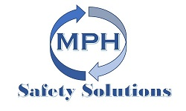

**Health of my Safety Satisfaction Survey**

Client Survey

Business “*Health of my Safety”* Satisfaction Survey

The objective of this survey today is to look at the Health **of** Safety in your business. There are some questions in this survey that are scored from 1 up to 5. This is just to give you an overall snapshot of how the “Health of the Safety “is in your business. The outcome is to give you a winning strategy for the future of safety management in your business.

I use the term Team Member instead of Worker or Employee. Your Team is the best Safety Process you can have in a business. If the Team works as a Team to all embrace a positive safety focused culture with you as the Coach and Mentor your business will thrive. My objective is to help your business really kick some safety goals

Safety in the workplace is really healthy when it is part of every decision, we make in our day to day work activities in whatever type of business you are in!

Whether your busines cuts hair, drives a tractor, types on a keyboard, tames lions or Pilots hot air balloons. The interaction of the People in your team and the “how when where what and why” of their activities has a direct impact on their health and safety and the health and safety of other Team members, Visitors and the Public.

**So, lets starts with some questions about you and your business**

Can you describe in a few brief details your Business?

Number of Team Members

Work Types

Full Time _________

Part Time _________

Contractors ____________

How many Team Members does your Business have in your Main Workplace every day?

Number _________

* How many Team Members work remotely from the main worksite on a daily basis?

______________

* Of your Team how many roles are Administration activity

____________

* Of your Team how many roles are Trade or Non-Trade type of work?

________________

* Do you and your Team start the Day with a Safety Prestart Meeting (Toolbox Meeting)

Yes

No

* Does your business have work Vehicles?

Yes

No

* What type of vehicle is used to carry out your Business activities?

Light Vehicles (Vans, Utes, Passenger Vehicles)

Yes

No

* Does your Business use High Risk plant (Forklifts, EWP)?

Yes

No

* Does your business use other Types of Mobile Plant?

Types of Plant _______________________________

* Does your business use any Specialised types of Tooling or Plant?

_____________________________

Thanks, this is great.

**The next few questions are answered from 1 being low / poor up to 5 being high / Very Well.**

* How well do you believe you understand your Work Health and Safety Obligations and Responsibilities under the Work Health and Safety Act, Regulation and Codes of Practise?

1. 2. 3. 4. 5.

* How well do you believe your Team understand their Work Health and Safety Obligations and Responsibilities under the Work Health and Safety Act, Regulation and Codes of Practise?

1. 2. 3. 4. 5.

* How well do you feel your business manages the risks that arise from using Chemicals?

1 2. 3. 4. 5.

* How well do you feel your business manages the risk to Team Members of Musculoskeletal injury?

1 2. 3. 4. 5.

* How well does your business manage Team Members working at height where there is a risk of a fall from one height to another (Including the use of Ladders and Work platforms)

1 2. 3. 4. 5.

* How well does your business manage Team Members working in a defined confined space?

1 2. 3. 4. 5.

* How well does your business manage Chemicals in the workplace, (Do you have current SDS for all Chemicals, do you have a hazardous Chemicals Register . How well do you store your Chemicals? )

1 2. 3. 4. 5.

* How well does your business manage traffic in the workplace, the interaction between light /heavy vehicles, mobile plant and pedestrians

1 2. 3. 4. 5.

* How well does your business manage Noise in the workplace, (Noise control systems, Noise/Vibration reduction to plant and machinery, Provision of Training and PPE Audiometric Testing for Team members)

1 2. 3. 4. 5

* How well does your business manage Dust and Fumes in the workplace, (Dust control systems, Bagging filtering systems, dust extraction air monitoring, Provision of Training and PPE Health Monitoring)

1 2. 3. 4. 5

* How well does your business manage Electrical Risk in the workplace (Regular inspections, Electrical Equipment Register, Testing and Tagging in line with Regulatory requirements only licensed electrical workers doing electrical work )

1 2. 3. 4. 5

* Over all, how well does your business manage risks overall in your business

1 2. 3. 4. 5

Out of a score of 55 how did you score?

* Do you carry out a formal induction for new and existing Team Members?

Yes

No

* As part of this Induction Process do you ensure that all licenses and Qualifications required for Work roles are provided and are in date?

Yes 

No 

* Does your business carry out a Training needs analysis for new and Existing Team Members?

Yes

No

* Does your business have a Training matrix?

Yes

No

* Does the Matrix capture all licenses and qualification dates of renewal?

Yes 

No 

Thanks for your participation in this activity today.

MPH Safety Solutions can assist to “plug the gaps “that may be evident in your safety management systems. This survey today gives a snap shot of how safety is managed in your business across a number of important areas.

The Safety management of your business is integral to your overall business success.

Successful safety management does not need to be complex or difficult to implement, what good safety management can do is to give your business the edge in a competitive market.

For an in-depth analysis and ongoing support please contact me today on

Ph 0423004020

Email [mhall@mphsafetysolutions.com](mailto:mhall@mphsafetysolutions.com)

[www.mphsafetysolutions.com.au](http://www.mphsafetysolutions.com.au)

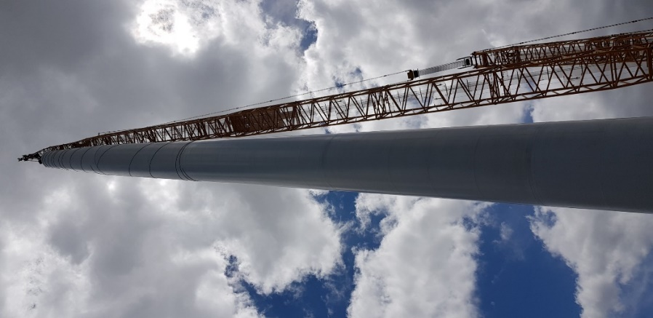

*Take your Training and Safety to new Heights*